**Data & AI Boot-Kon Event**

| **Title: Machine Learning Operations with Vertex AI** | | **Goal of the lab**   * Understand MLOPS steps in Vertex AI * Learn about BigQuery and Vertex AI integration * Apply machine learning operations on the use case dataset. * Create an ML model with explainability. |
| --- | --- | --- |
| **Author**: Wissem Khlifi | **Date**: 2024-04-01 | **Estimated Completion Time**: 45 Minutes |
|  | | |

CAUTION:

This lab is for educational purposes only and should be used with caution in production environments. Google Cloud Platform (GCP) products are changing frequently, and screenshots and instructions might become inaccurate over time. Always refer to the latest GCP documentation for the most up-to-date information.

# **Architecture Diagram:**

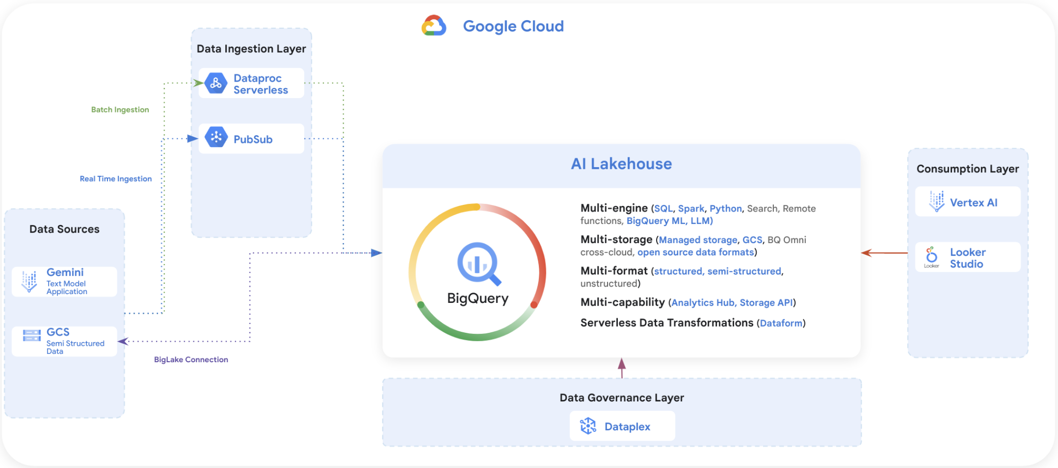

*Please review the permissions information detailed in each section before running the labs from the Jupyter notebooks.*

## ***LAB Section : Data exploration and preparation using Vertex AI workbench***

Continue the journey with notebooks available at: https://github.com/dace-de/bootkon-h2-2024/tree/main/notebooks

In LAB1 , you have created a notebook instance called for example “bootkon”. We will continue our ML journey using this notebook instance.

Go to Vertex AI > Workbench > OPEN JUPYTER LAB



Note: You may have to wait for the notebook instance to start. If it was inactive, it might have been shut down automatically to save costs.

Follow the Instructions in the Notebooks: The notebook files should be saved under the notebooks directory of your notebook instance. Follow the order of the notebooks.

### ***Notebook 0: Environment setup***

File: 00 - Environment Setup.ipynb

***Note:*** You can skip enabling the Cloud Resource Manager API as this should have been done during LAB 1. Additionally, your compute engine service account should not have rights to enable the APIs.

### ***Notebook 1: Data Exploration and Preparation***

File: 01 - BigQuery - Table Data Source.ipynb

***Dependency: Notebook 0***

**Note**: You might get a PermissionDenied: 403 request failed: the user does not have ***'bigquery.readsessions.create'*** permission for 'projects/<your project id>'. In this case, grant the compute service account the ***BigQuery Read Session User role***. More information can be found [here](https://cloud.google.com/bigquery/docs/reference/storage).

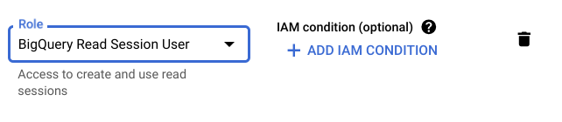

**Note**: Notice how unbalanced the data is between classes. This is normal in fraud detection or anomaly detection type of problems.

## ***LAB Section : ML Training and Prediction***

***Note: Notebooks 2 and 3 can be run simultaneously, as they are independent tasks.***

### ***[LAB] AutoML : Training and Prediction Notebook 2:***

File: 02 - Vertex AI - AutoML.ipynb

***Dependency: Notebook 0 & Notebook 1***

**Note**: If you receive a PermissionDenied: 403 Permission ***'aiplatform.datasets.create'*** denied error. You need to grant the compute service account the ***AI Platform Developer*** role and ***Vertex AI User*** role.

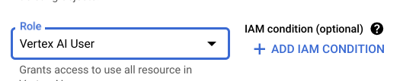

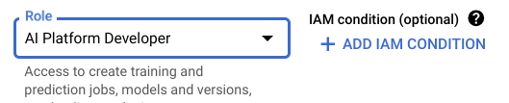

## ***LAB Section : ML Pipeline Automation***

***Note: Notebooks 2 and 3 can be run simultaneously, as they are independent tasks.***

### ***[LAB]MLOPS: AutoML automated pipeline Notebook 3:***

File: 03 - Vertex AI _ Pipelines - AutoML automated pipeline.ipynb

***Dependency: Notebook 0 & Notebook 1***

#### *Note: You can start Hands-on Lab 5 while the Hands-on Lab 4 training jobs in Notebooks 2 & 3 are still running.*

**🥳🥳Congratulation you have successfully completed LAB 4 🥳🥳**

[OPTIONAL HOMEWORK CHALLENGE LAB] Enhance Model Architecture using Custom Tensorflow Models

***Hint:*** *Utilize* [*Tensorflow IO*](https://www.tensorflow.org/io) *and the SMOTE (Synthetic Minority Oversampling Technique) to potentially improve results.*